// Michael Haley

// Lab 3a

// This program will take three grade inputs and calculate their average. Then. the three grades will be printed, each on one line with a description. Each grade will have a print field of 6 spaces.

// Each grade will be displayed with 2 digits after the decimal, with trailing point zeroes displayed.

// Then the average will be printed to the screen.

// A general rule of descriptive prompts and labeled/descriptive outputs will be followed.

#include <iostream> // required for taking input and printing output

#include <iomanip> // required for setw & other formatting.

using namespace std; // sets the program to use the std namespace

int main() // the main function, core to any c++ program.

{ // curly bracket to begin enclosing the program

double testOne, testTwo, testThree, averageValue; // declares the double variables

cout << "This program will help you visualize your test grades so far." << endl; // a greeting to the user, explaining the basic purpose of the program

cout << "You will be prompted to enter your grades (in decimal format) for test 1, test 2, and test 3." << endl; // prepares the user to be prompted, and details the kind of information they should input.

cout << "Please enter your grade as a decimal for test 1: "; //prompt

cin >> testOne; // assigns user input to double variable testOne

cout << "Please enter your grade as a decimal for test 2: "; //prompt

cin >> testTwo; // assigns user input to double variable testTwo

cout << "Please enter your grade as a decimal for test 3: "; //prompt

cin >> testThree; // assigns user input to double variable testThree

averageValue = ( testOne + testTwo + testThree ) / 3; // calculate the average test score and assigns that value to the double variable average

// i took the liberty of using an extra setw(25) [this is the width of the longest string] for the labelling text below to make it more readable.

cout << setw(25) << "Test one score: " << setw(6) << setprecision(2) << fixed << testOne << endl; // displays the formatted line with test one score

cout << setw(25) << "Test two score: " << setw(6) << testTwo << endl; // displays the formatted line with test two score

cout << setw(25) << "Test three score: " << setw(6) << testThree << endl; // displays the formatted line with test three score

cout << setw(25) << "Average of three scores: " << setw (6) << averageValue << endl; // displays the formatted line with test average score

return 0; // if the program gets here, it is successful, and ends without error.

} // curly bracket to end enclosing the program, the last character in any program I have seen so far.

Run 1:

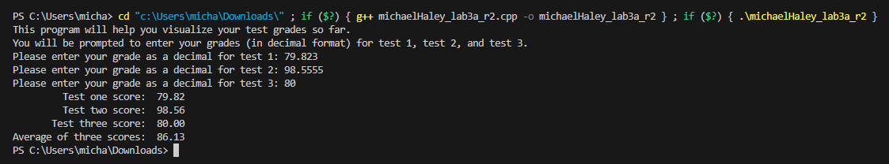

Run 2:

